**SQL Assignment-3**

**Retrieve data using Group By clause**

CREATE TABLE Department

(

dept_id INT IDENTITY(1001,1) PRIMARY KEY,

dept_name VARCHAR(20)

);

CREATE TABLE Employee

(

emp_id INT IDENTITY(1,1) PRIMARY KEY,

dept_id INT ,

mngr_id INT ,

emp_name VARCHAR(20),

salary INT

);

INSERT INTO Employee VALUES

('1002','502','Vivek','35000'),

('1004','502','Archan','20000'),

('1001','503','Vaidik','15000'),

('1003','504','Yash','50000'),

('1004','501','Jayesh','45000'),

('1001','503','Manish','37000'),

('1002','502','Harshil','25000'),

('1003','503','Sagar','17000'),

('1001','501','Bhavesh','35500'),

('1001','504','Tushar','47500'),

('1002','504','Dhaval','27500'),

('1004','502','Dinesh','49000');

INSERT INTO Department VALUES ('Finance'),

('Marketing'),

('Production'),

('Audit');

SELECT * FROM Department;

SELECT * FROM Employee;

1)write a SQL query to find Employees who have the biggest salary in their Department

SELECT E.emp_name , D.dept_name, E.salary

FROM Employee E

JOIN Department D

ON D.dept_id = E.dept_id

WHERE E.salary IN (SELECT MAX(salary) FROM Employee GROUP BY dept_id);

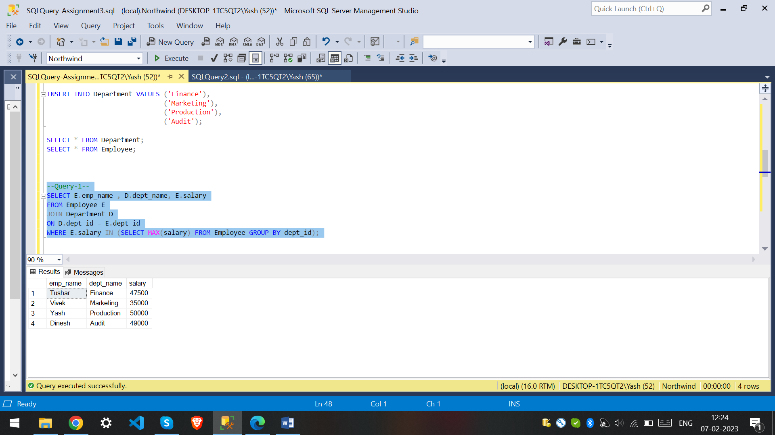

2) write a SQL query to find Departments that have less than 3 people in it.

SELECT D.dept_name

FROM Employee E

JOIN Department D

ON D.dept_id = E.dept_id

GROUP BY D.dept_name

HAVING COUNT(E.dept_id)<3;

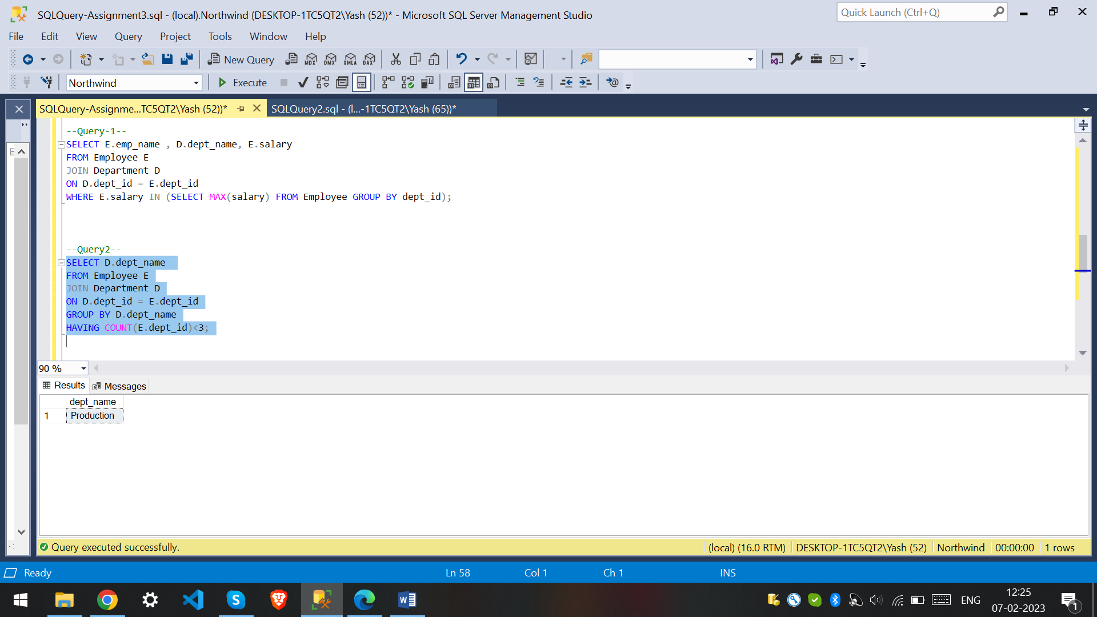

3) write a SQL query to find All Department along with the number of people there.

SELECT D.dept_name , COUNT(E.dept_id) AS Total_employees

FROM Department D

INNER JOIN Employee E

ON D.dept_id = E.dept_id

GROUP BY dept_name;

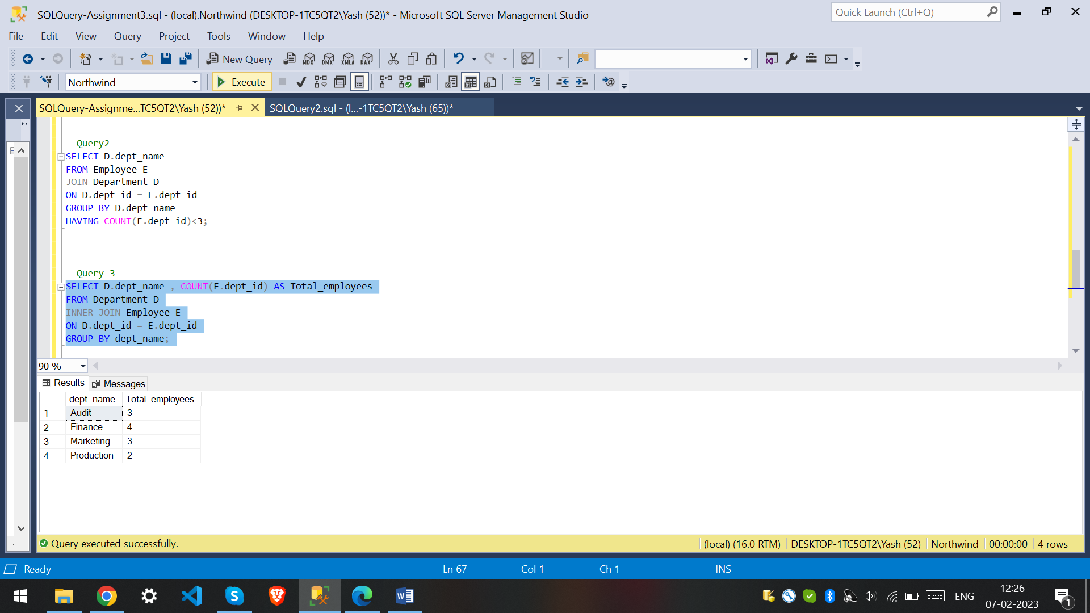

4) write a SQL query to find All Department along with the total salary there.

SELECT D.dept_name , SUM(E.salary) AS Total_salary

FROM Department D

INNER JOIN Employee E

ON D.dept_id = E.dept_id

GROUP BY dept_name;

